

Capstone Project Report
Report 3 – Software Requirement Specification

– HoChiMinh, January 2025 –
Contents
I. Record of Changes 2
II. Software Requirement Specification 3
1. Product Overview 3
2. User Requirements 4
2.1 Actors 4
2.2 Use Cases 5
3. Functional Requirements 9
3.1 System Functional Overview 9
3.2 Web application features 18
3.2.1 Create Booking 18
Function Trigger 18
Function Description 18
Screen Layout 18
Function Details 19
3.2.2 View Booking Details 19
Function Trigger 19
Function Description 19
Screen Layout 19
Function Details 20
3.3 Driver Management 20
3.3.1 Assign Driver 20
Function Trigger 20
Function Description 20
Screen Layout 20
Function Details 20
4. Non-Functional Requirements 21
4.1 External Interfaces 21
4.2 Quality Attributes 21
5. Requirement Appendix 21
5.1 Business Rules 21
5.2 Common Requirements 23
5.3 Application Messages List 23

I. Record of Changes
Date | A*  M, D | In charge | Change Description
06/02/2525 | A
28/02/2025 | A
*A - Added M - Modified D - Deleted

II. Software Requirement Specification

1. Product Overview
Product Overview
VinShuttle is an innovative electric vehicle booking application designed to streamline intra-area transportation within large residential communities, specifically targeting VinHome Grand Park (VHGP) in Ho Chi Minh City. The platform aims to address the inefficiencies and inconveniences of traditional transportation methods by offering a user-friendly, eco-friendly, and centralized solution for residents to book electric shuttles. By integrating advanced features such as real-time tracking, route optimization, and payment, VinShuttle enhances mobility while promoting sustainability within the community.

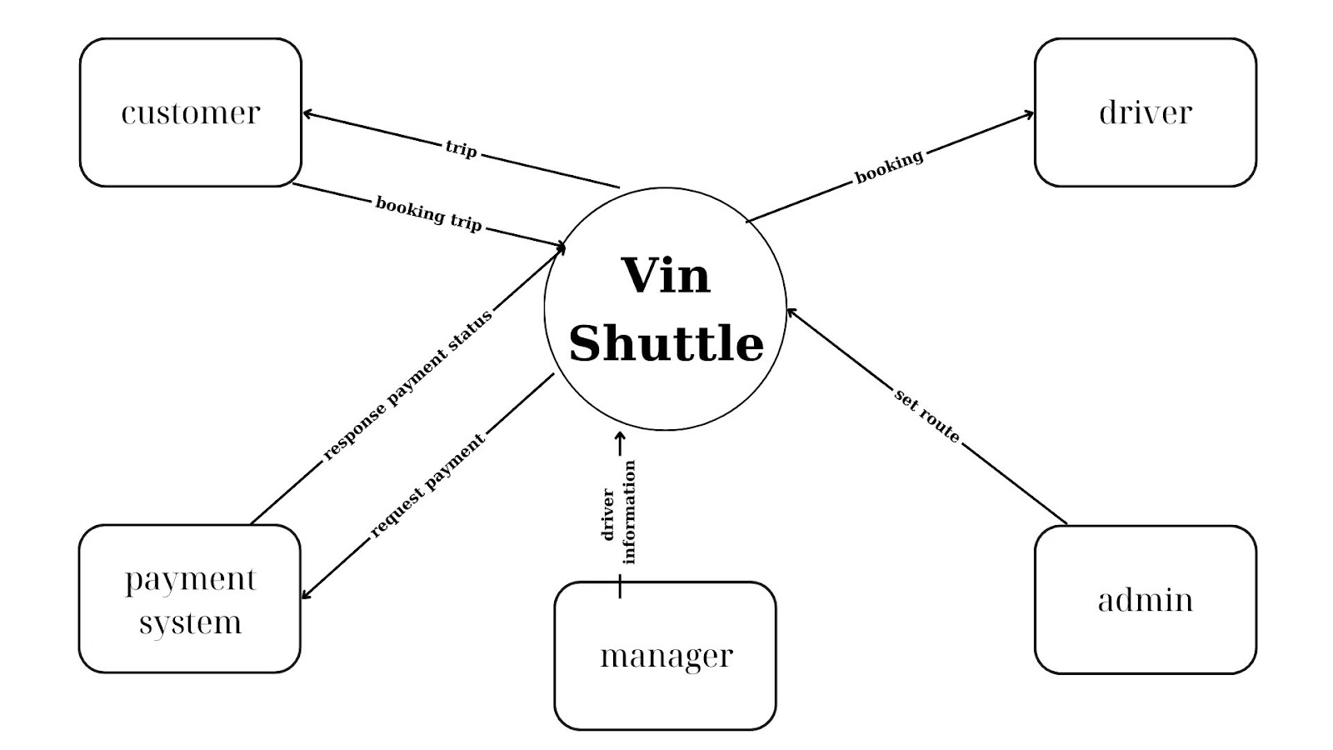

2. User Requirements

2.1 Actors
# | Actor | Description
1 | Administrator | Who is responsible for managing the system and permission.
2 | Manager | The Manager oversees drivers, customers, and bookings, managing schedules and feedback.
3 | Customer | The Customer books rides, tracks trips, provides feedback, and manages their profile.
4 | Driver | The Driver manages bookings, schedules, routes, and communication.

2.2 Use Cases

2.2.1 Diagram(s)
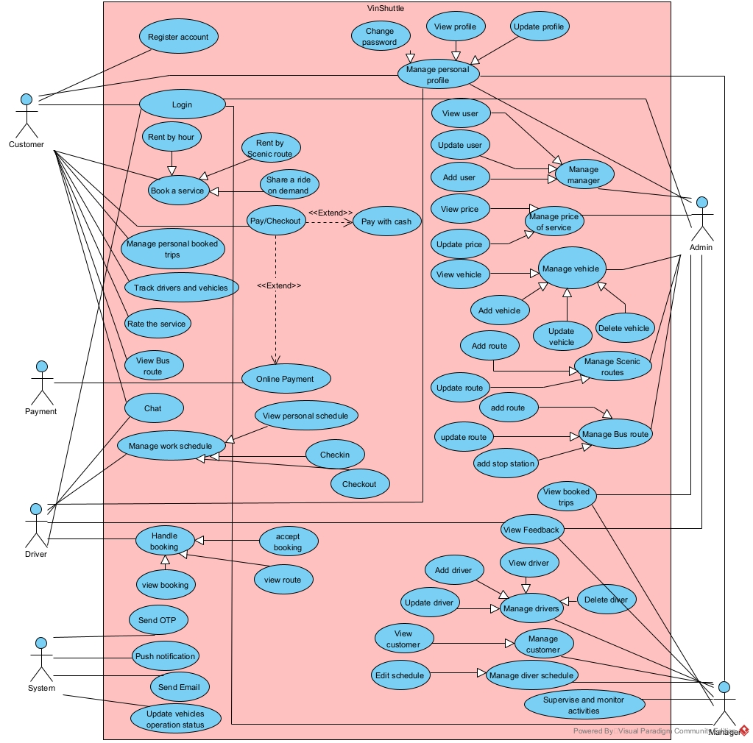

2.2.2 Descriptions
ID | Use Case | Actors | Use Case Description
UC-01 | Register account | Customer | The customer creates a new account to use the service.
UC-02 | Login | Customer | The customer logs into the system using their account credentials.
UC-03 | Rent by hour | Customer | The customer books a vehicle on an hourly basis.
UC-04 | Rent by Scenic route | Customer | The customer books a ride following a predefined route.
UC-05 | Share on-demand ride | Customer | The customer shares a ride on demand.
UC-06 | Book a service | Customer | The customer books a transportation service.
UC-07 | View Bus route | Customer | The customer view the bus route and bus position to catch the bus.
UC-08 | Manage booked trips | Customer | The customer manages their booked trips.
UC-09 | Track drivers and vehicles | Customer | The customer tracks the real-time location of drivers and vehicles.
UC-10 | Rate the service | Customer | The customer rates the service after a ride.
UC-11 | Give feedback | Customer | The customer provides feedback about the service.
UC-12 | View personal schedule | Driver | The driver views their personal work schedule.
UC-13 | View booking | Driver | The driver views assigned bookings.
UC-14 | Accept booking | Driver | The driver accepts a booking request.
UC-15 | View route | Driver | The driver checks the route for an accepted booking.
UC-16 | Manage work schedule | Driver | The driver manages their work schedule.
UC-17 | Check-in | Driver | The driver checks in when starting work.
UC-18 | Check-out | Driver | The driver checks out after completing their shift.
UC-19 | Chat | Driver, Customer | The driver and customer communicate via chat.
UC-20 | View profile | Customer, Manager,  Admin,  Driver | Users view their personal profile information.
UC-21 | Update profile | Customer, Manager,  Admin,  Driver | Users update their personal profile information.
UC-22 | Edit schedule | Manager | The manager edits and manages driver schedules.
UC-23 | View feedback | Manager,  Admin,  driver | The manager, admin, and driver reviews customer feedback.
UC-24 | Manage drivers | Manager | The manager adds, updates, and removes driver information.
UC-25 | Manage customers | Manager | The manager view customer information.
UC-26 | View Booked Trip | Manager,  Admin | View the booked trip by customer.
UC-27 | Manage vehicles | Admin | The admin manages vehicle information.
UC-28 | Manage Scenic routes | Admin | The admin handles Scenic routes in the system.
UC-29 | Manage Bus routes | Admin | The admin handles Bus routes in the system.
UC-30 | Supervise and monitor activities | Manager | The manager supervises and monitors system activities.
UC-31 | Send OTP | System | Send OTP by SMS to customer when login.
UC-32 | Push notification | System | Send Notification to client
UC-33 | Send Email | System | Send email to user about the new notification.
UC-34 | Update vehicles operation status | System | Update vehicle operating status by time of day and work shifts.

3. Functional Requirements

3.1 System Functional Overview

3.1.1 Screens Flow

3.1.1.1Customer Screen Flow
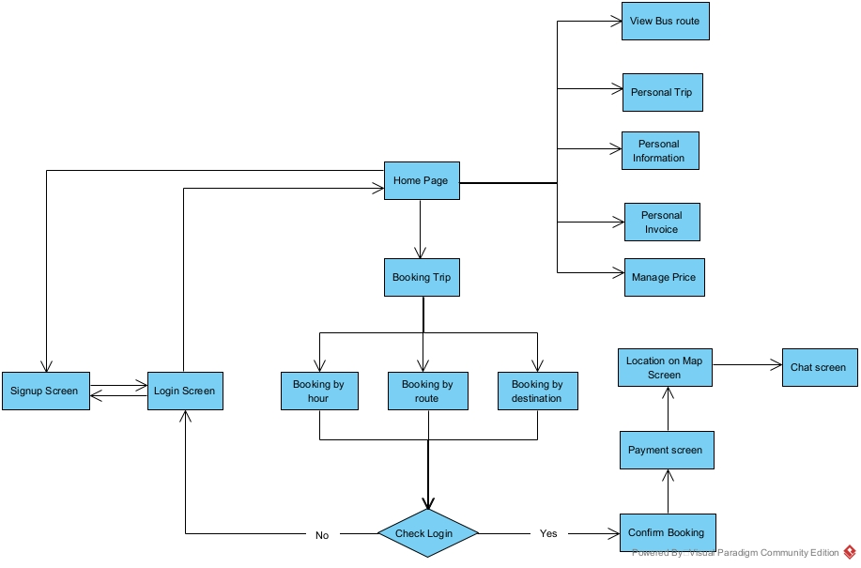

3.1.1.2Driver Screen Flow
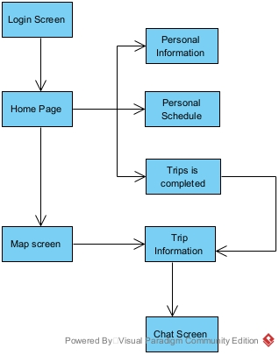

3.1.1.3Manager Screen Flow
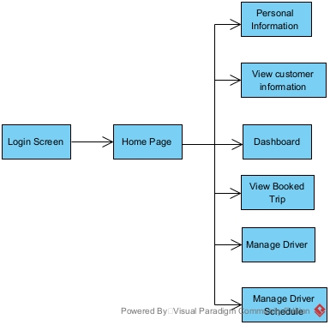

3.1.1.4Admin Screen Flow
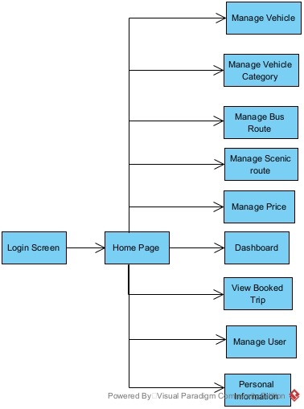

3.1.2 Screen Descriptions
# | Feature | Screen | Description
Customer Screen Flow
1 | Booking | Booking trip | Allows the user to choose the booking type
2 | Booking | Booking by hour | Enables customers to book a trip based on hourly service.
3 | Booking | Booking by route | Allows customers to book a trip following a predefined route,
4 | Booking | Booking by destination | Enables customers to book a trip to a specific destination.
5 | Booking | Confirm Booking | Final confirmation before completing the booking.
6 | Chat | Chat screen | Allows customers to communicate with support or drivers.
7 | Booking | Location on Map Screen | Displays the trip location and route on a map.
8 | Logout | User Profile Screen | Allows customers to log out of the system
9 | Show all services | Home Page | Allows customers to view services and navigate pages
10 | Sign up | Signup Screen | Allows customers to sign up
11 | Login | Login Screen | Allows customers to login
Admin Screen Flow
12 | Login | Login Screen | Admin authentication screen.
13 | Navigate | Home Page | Main navigation hub
14 | Management Vehicle | Manage Vehicle | Manage vehicle information
15 | Management Vehicle Category | Manage Vehicle Category | Organize vehicle categories
16 | Management Bus Route | Manage Bus Route | Configure bus routes
17 | Management Scenic Route | Manage Scenic Route | Set up scenic routes
18 | Dashboard | Dashboard | Overview of key metrics
19 | Management Price | Manage Price | Configure pricing details
20 | Management Users | Manage Users | Manage user accounts.
21 | Profile | Personal Information | View and edit profile details.
Driver Screen Flow
22 | Login | Login Screen | Users log in to access the system.
23 | Navigate | Home Page | The main hub for navigation to different features.
24 | View Profile | Personal Information | View and update personal details.
25 | View Schedule | Personal Schedule | Check assigned trip schedules.
26 | Trips is Completed | Trip History | View the history of completed trips.
27 | View Routes & Vehicles | Map Screen | Display vehicle locations and assigned routes.
28 | Trip Details | Trip Information | View details of ongoing or upcoming trips.
29 | Communication | Chat Screen | Communicate with other users or support.
Driver Screen Flow
30 | Login | Login Screen | Users log in to access the system.
31 | Navigate | Home Page | The main hub for accessing management features.
32 | View Profile | Personal Information | View and update personal details.
33 | View Customer Details | View Customer Information | Access customer information and history.
34 | Monitor System | Dashboard | View system analytics and key metrics.
35 | View Booked Trips | View Booked Trip | See details of booked trips.
36 | Manage Drivers | Manage Driver | Add, remove, or update driver details.
37 | Manage Schedules | Manage Driver Schedule | Assign and modify driver schedules.

3.1.3 Screen Authorization

# | Screen | Admin | Manager | Customer | Driver
1 | Booking trip |  |  | ✓
2 | Booking by hour |  |  | ✓
3 | Booking by route |  |  | ✓
4 | Booking by destination |  |  | ✓
5 | Confirm Booking |  |  | ✓
6 | Chat screen |  |  | ✓ | ✓
7 | Location on Map Screen |  |  | ✓ | ✓
8 | User Profile Screen |  |  | ✓ | ✓
9 | Signup Screen |  |  | ✓
10 | Login Screen | ✓ | ✓ | ✓ | ✓
11 | Home Page | ✓ | ✓ | ✓ | ✓
12 | Manage Vehicle | ✓ | ✓
13 | Manage Vehicle Category | ✓ | ✓
14 | Manage Bus Route | ✓ | ✓
15 | Manage Scenic Route | ✓ | ✓
16 | Dashboard | ✓ | ✓ |  | ✓
17 | Manage Price | ✓ | ✓
18 | Manage Users | ✓ | ✓
19 | Personal Information | ✓ | ✓ | ✓ | ✓
20 | Personal Schedule |  |  |  | ✓
21 | Trip History |  |  |  | ✓
22 | Map Screen |  |  |  | ✓
23 | Trip Information |  |  |  | ✓
24 | View Customer Information | ✓ | ✓
25 | View Booked Trip | ✓ | ✓
26 | Manage Driver | ✓ | ✓
27 | Manage Driver Schedule | ✓ | ✓

3.1.4 Non-Screen Functions
# | Feature | System Function | Description
1 | Send OTP | Send OTP via SMS | Send OTP via SMS to customer to verify when login by phone.
2 | Send Email | Send Email to user | Send Email when manager create driver account, Invoice about booking,...
3 | Push notification | Push notification to client | Push notification to user client when something new, status change,..
4 | Update vehicles operation status | Update vehicles operation status | Update vehicle operating status by time of day and work shifts.

3.1.5 Entity Relationship Diagram
[Provide the entity relationship diagram and the entity descriptions in the table format as below]
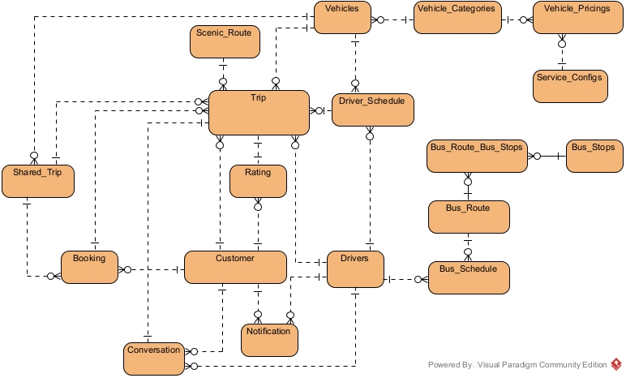
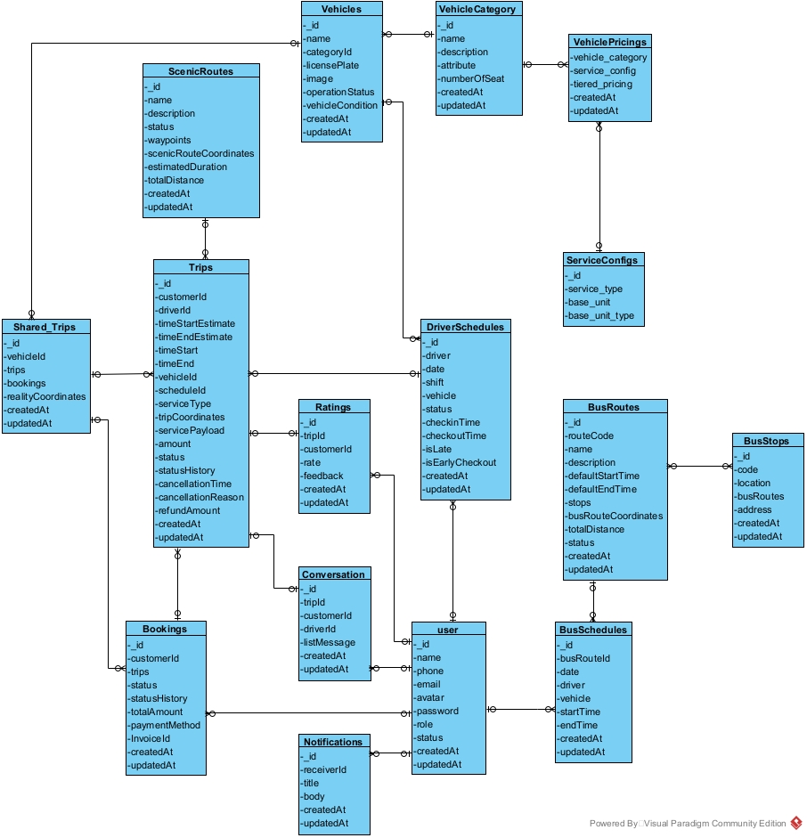
Entities Description
# | Entity | Description
1 | Customer | Customer of the system
2 | Drivers | Drivers of the system
3 | Trip | Trip booked by the customer
4 | Booking | Booking of the trips by the customer
5 | Vehicles | Vehicles of the system
6 | Vehicle_Categories | Vehicle Categories of the system
7 | Vehicle_Pricings | regulations on price ranges of vehicles and services of system
8 | Service_Configs | regulations on types of units and standard units to calculate the price of each type of service of system
9 | Driver_Schedule | Driver Schedule by shift of system
10 | Bus_Route | Bus Route of the system
11 | Bus_Stops | Bus Stops for bus route using of the system
12 | Scenic_Route | Scenic Route is a route created by the manager to serve sightseeing services according to the route of system
13 | Conversation | Conversation of the driver and customer by trip
14 | Shared_Trip | stores shared type trips that are matched together
15 | Rating | Rating of customer for trip
16 | Notification | Notification for user of system

3.2 Web application features

3.2.1 Create Booking

Function Trigger
- Navigation Path: Home Page → Booking → Create New Booking
- Trigger Condition: User selects "Book a Ride" button

Function Description
- Actors/Roles: Customer, Admin, Manager
- Purpose: Allows customers to book a vehicle for transportation.
- Interface: Users provide details such as pickup location, drop-off location, date, time, and vehicle type.
- Data Processing:
  - Validate input fields (e.g., date should not be in the past, required fields must be filled).
  - Save booking details in the database.
  - Notify available drivers.

Screen Layout
- A form with the following fields:
  - Pickup Location (text field with location auto-suggestion)
  - Drop-off Location (text field with location auto-suggestion)
  - Booking Date (date picker)
  - Booking Time (time picker)
  - Vehicle Type (dropdown: Sedan, SUV, Van, etc.)
  - Submit Button

Function Details
- Data Fields & Validation:
  - Pickup & Drop-off locations: Required, must be valid addresses.
  - Booking Date: Required, cannot be in the past.
  - Booking Time: Required, must align with operating hours.
  - Vehicle Type: Required, must be one of the available options.
- Business Rules:
  - Customers can only book vehicles available at the selected time.
  - If no drivers are available, the booking is added to a waitlist.
  - Admins and Managers can override booking constraints.
- Functionalities:
  - Successful booking redirects the user to the confirmation page.
  - Errors (e.g., missing fields, unavailable vehicle) trigger alert messages.

3.2.2 View Booking Details

Function Trigger
- Navigation Path: Home Page → Booking → View Booking History
- Trigger Condition: User selects a past or current booking.

Function Description
- Actors/Roles: Customer, Admin, Manager, Driver
- Purpose: Allows users to view booking details, including status and assigned driver.
- Interface:
  - Booking ID, Status, Payment Details, Vehicle Info, Driver Info
  - Cancellation Option (if applicable)

Screen Layout
- A detail page showing:
  - Booking ID
  - Pickup & Drop-off locations
  - Date & Time
  - Vehicle Type
  - Driver Details (if assigned)
  - Payment Status
  - Cancellation Button (if allowed)

Function Details
- Business Rules:
  - Customers can only view their own bookings.
  - Admins & Managers can view all bookings.
  - Drivers can view assigned bookings.
- Functionalities:
  - Active bookings show driver contact information.
  - Canceled bookings are marked with reason & timestamp.

3.3 Driver Management

3.3.1 Assign Driver

Function Trigger
- Navigation Path: Admin/Manager Dashboard → Assign Driver
- Trigger Condition: Admin or Manager selects an unassigned booking.

Function Description
- Actors/Roles: Admin, Manager
- Purpose: Allows assignment of available drivers to customer bookings.
- Interface: List of bookings & available drivers for selection.

Screen Layout
- List of unassigned bookings.
- Dropdown to select an available driver.
- Confirm Button.

Function Details
- Business Rules:
  - Only available drivers are listed.
  - Once assigned, driver details are sent to the customer.
- Functionalities:
  - Drivers receive a notification upon assignment.
  - Admins/Managers can reassign drivers if needed

4. Non-Functional Requirements

4.1 External Interfaces

User Interface: The system must provide an intuitive, responsive UI accessible on various devices, including desktops, tablets, and smartphones.

APIs: The system must integrate with external services such as payment gateways, map services, and third-party authentication providers.

Notifications: The system must support email, SMS, and push notifications for booking confirmations, reminders, and updates.

Security: The system must ensure user data protection through encryption and secure authentication methods.

Scalability: The system must be able to handle an increasing number of users and transactions without performance degradation.

Performance: The system must have a fast response time to user actions, ensuring smooth user interactions.

Logging and Monitoring: The system must provide logging and monitoring capabilities to track system performance and detect anomalies.

4.2 Quality Attributes
- Performance: The system should respond to user actions within 2 seconds under normal load conditions.
- Reliability: The system must have an uptime of over 80% a year to ensure critical services are always available.
- Security: Using Third-party to hide API.
- Usability: The interface should be user-friendly.
- Maintainability: The system architecture supports easy updates.

5. Requirement Appendix

5.1 Business Rules
ID | Rule Definition
BR-01 | User roles must be clearly defined, and access permissions must be enforced based on these roles to ensure appropriate access control
BR-02 | Data entered into the system must be validated for integrity prior to processing
BR-03 | Admin, Manager, and Driver must have a Google account to login.
BR-04 | Each phone number/email is registered to only one account.
BR-05 | Customers must have a phone number to login.
BR-06 | Customers must verify OTP has been sent to login.
BR-07 | OTP is valid for 2 minutes and can only be used once.
BR-08 | Only Admin can manage the price of service.
BR-09 | Only Admin can manage vehicles.
BR-10 | Only Admin can manage Scenic routes.
BR-11 | Only Admin can manage Bus routes.
BR-12 | Only Admin can view all user information.
BR-13 | Only Admin can create a Manager.
BR-14 | The Bus routes need more than 2 stations.
BR-15 | Only Managers can create drivers.
BR-16 | Only Managers and Admin can view all booked trips in the system.
BR-17 | Only Managers can edit the driver schedule.
BR-18 | Drivers and customers can view their personal trip.
BR-19 | A conversation between driver and customer is created automatically after a booking is created.
BR-20 | Conversation between driver and customer automatically closes 24 hours after the trip ends.
BR-21 | Drivers can only view their personal schedule.
BR-22 | Drivers can edit their profile.
BR-23 | Driver can view the rate and feedback of the trip.
BR-24 | Drivers will only receive bookings if there are no scheduled trips and are on shift.
BR-25 | Drivers must check-in before shift and check out after shift.
BR-26 | Driver cannot check-out if the trip is unfinished.
BR-27 | Shifts can last up to 15 minutes if a trip is in progress.
BR-28 | The vehicle's operating status is automatically updated when the vehicle has a trip, ends a trip, changes shifts, etc.
BR-29 | System response vehicles suitable for customer needs.
BR-30 | Customers can edit their profile.
BR-31 | Customers can only see the vehicle's location during the current trip.
BR-32 | Customers can only view Scenic Routes and Bus Routes that have been made public
BR-33 | Customers can only see the locations of all running buses of the Bus Route service.
BR-34 | Customers need to provide a pick up point when booking.
BR-35 | Customers are only rated after the trip is completed.
BR-36 | Car/driver can only be booked if the status is active.
BR-37 | Share a ride on demand, route changes do not exceed 2km and 8 minutes.
BR-38 | Rent by hour and Rent by Scenic route must be paid in advance.
BR-39 | Rent by hour must have a minimum duration of 0.5 hours and a maximum of 5 hours.
BR-40 | With Rent by hour and Rent by Scenic route, Customers can only cancel flights 2 hours before departure time.
BR-41 | The number of people participating in the shared trip must not exceed the maximum number of seat.

5.2 Common Requirements
The system must perform automated daily data backups to ensure the safety of user information.
Online help features and tooltips powered by AI must be implemented to enhance the user experience.
The system must meet specific performance standards under both normal and peak load conditions.
User interfaces must comply with usability standards to ensure an understandable experience for all user types, including Administrators, Manager, and Customers, Driver.

5.3 Application Messages List

# | Message code | Message Type | Context | Content
1 | MSG01 | In red, under the text box | User forgot to input email or password | Email and password is required
2 | MSG02 | In line | User is empty | No user data found
3 | MSG03 | In line | Search empty | No data found
4 | MSG04 | In line | Request is empty | No request found
5 | MSG05 | Toast message | Accept request | Accepted
6 | MSG06 | Toast message | Reject request | Rejected
7 | MSG7 | Toast message | User role is not allow to sign in the application | This account doesn’t have permission to access this application
8 | MSG8 | Toast message | Email or password is not existed | Email is not existed or password is not correct
9 | MSG9 | In red, under the text box | User enter an invalid email | Please enter a valid email address
10 | MSG10 | In red, under the text box | User enter a password with less than 5 characters | Password must have more than 5 characters
11 | MSG11 | Toast message | Create successfully | Create successfully
12 | MSG12 | Toast message | Create unsuccessfully | Cannot create
13 | MSG13 | Toast message | Update successfully | Update successfully
14 | MSG14 | Toast message | Update unsuccessfully | Cannot update

